**OSPF**

**Multi Area**

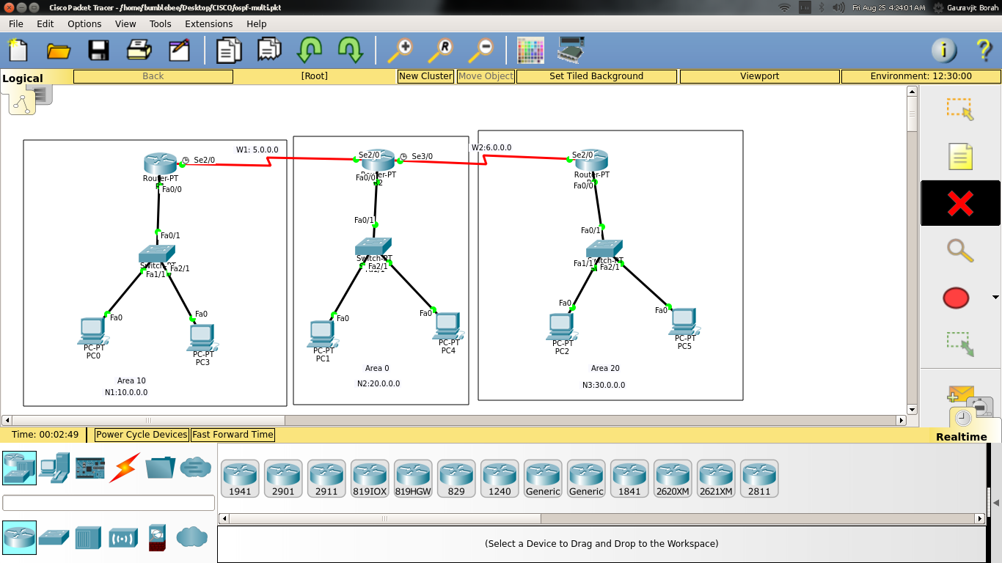

|  |  |  |  |  |  |  |  |
| --- | --- | --- | --- | --- | --- | --- | --- |
| **Name** | **N/k Addr** | **Subnet Mask** | **Wildcard Mask** | **CIDR** | **Default-Gateway** | **Host Addr Range** | **Broadcast Addr** |
| N1 | 10.0.0.0 | 255.0.0.0 | 0.255.255.255 | 8 | 10.0.0.1 | 10.0.0.1 - 10.255.255.254 | 10.255.255.255 |
| N2 | 20.0.0.0 | 255.0.0.0 | 0.255.255.255 | 8 | 20.0.0.1 | 20.0.0.1 - 20.255.255.254 | 20.255.255.255 |
| N3 | 30.0.0.0 | 255.0.0.0 | 0.255.255.255 | 8 | 30.0.0.1 | 30.0.0.1 - 30.255.255.254 | 30.255.255.255 |
| W1 | 5.0.0.0 | 255.0.0.0 | 0.255.255.255 | 8 | - | 5.0.0.1 - 5.255.255.254 | 5.255.255.255 |
| W2 | 6.0.0.0 | 255.0.0.0 | 0.255.255.255 | 8 | - | 6.0.0.1 - 6.255.255.254 | 6.255.255.255 |

**Router 1**

R1>show ip ospf database

OSPF Router with ID (1.1.1.1) (Process ID 1)

Router Link States (Area 10)

Link ID ADV Router Age Seq# Checksum Link count

1.1.1.1 1.1.1.1 1056 0x80000008 0x0093f5 3

2.2.2.2 2.2.2.2 1056 0x80000002 0x008321 2

Summary Net Link States (Area 10)

Link ID ADV Router Age Seq# Checksum

20.0.0.0 2.2.2.2 1052 0x80000001 0x0052ef

6.0.0.0 2.2.2.2 1033 0x80000002 0x007f90

30.0.0.0 2.2.2.2 943 0x80000003 0x004ea7

R1>show ip ospf neighbor

Neighbor ID Pri State Dead Time Address Interface

2.2.2.2 0 FULL/ - 00:00:31 5.0.0.2 Serial2/0

**Router 2**

R2>show ip ospf database

OSPF Router with ID (2.2.2.2) (Process ID 1)

Router Link States (Area 0)

Link ID ADV Router Age Seq# Checksum Link count

2.2.2.2 2.2.2.2 1141 0x80000002 0x00ef3e 1

Summary Net Link States (Area 0)

Link ID ADV Router Age Seq# Checksum

5.0.0.0 2.2.2.2 1131 0x80000001 0x008e83

10.0.0.0 2.2.2.2 1131 0x80000002 0x0055b5

6.0.0.0 2.2.2.2 1118 0x80000003 0x007d91

30.0.0.0 2.2.2.2 1028 0x80000004 0x004ca8

Router Link States (Area 10)

Link ID ADV Router Age Seq# Checksum Link count

2.2.2.2 2.2.2.2 1141 0x80000002 0x008321 2

1.1.1.1 1.1.1.1 1141 0x80000008 0x0093f5 3

Summary Net Link States (Area 10)

Link ID ADV Router Age Seq# Checksum

20.0.0.0 2.2.2.2 1137 0x80000001 0x0052ef

6.0.0.0 2.2.2.2 1118 0x80000002 0x007f90

30.0.0.0 2.2.2.2 1028 0x80000003 0x004ea7

Router Link States (Area 20)

Link ID ADV Router Age Seq# Checksum Link count

2.2.2.2 2.2.2.2 1043 0x80000002 0x00d7c3 2

3.3.3.3 3.3.3.3 1032 0x80000003 0x00d591 3

Summary Net Link States (Area 20)

Link ID ADV Router Age Seq# Checksum

20.0.0.0 2.2.2.2 1118 0x80000001 0x0052ef

5.0.0.0 2.2.2.2 1118 0x80000002 0x008c84

10.0.0.0 2.2.2.2 1118 0x80000003 0x0053b6

R2>show ip ospf neighbor

Neighbor ID Pri State Dead Time Address Interface

1.1.1.1 0 FULL/ - 00:00:39 5.0.0.1 Serial2/0

3.3.3.3 0 FULL/ - 00:00:36 6.0.0.2 Serial3/0

**Router 3**

R3>show ip ospf database

OSPF Router with ID (3.3.3.3) (Process ID 1)

Router Link States (Area 20)

Link ID ADV Router Age Seq# Checksum Link count

2.2.2.2 2.2.2.2 1101 0x80000002 0x00d7c3 2

3.3.3.3 3.3.3.3 1090 0x80000003 0x00d591 3

Summary Net Link States (Area 20)

Link ID ADV Router Age Seq# Checksum

20.0.0.0 2.2.2.2 1176 0x80000001 0x0052ef

5.0.0.0 2.2.2.2 1176 0x80000002 0x008c84

10.0.0.0 2.2.2.2 1176 0x80000003 0x0053b6

R3#show ip ospf neighbor

Neighbor ID Pri State Dead Time Address Interface

2.2.2.2 0 FULL/ - 00:00:31 6.0.0.1 Serial2/0